Prepositions of Manner

🔹 What Are Prepositions of Manner?
# Source: AI Source: Provided by: [Data Path: Persons Table -> ID Column: 1, Name_En Column: Motasem Essam] -> From: [Chatgpt (GPT-4-turbo)] on [7/28/2025]
Prepositions of manner show how something happens or the way an action is performed.
They answer the question: How? or In what manner?

✅ Common Prepositions of Manner
# Source: AI Source: Provided by: [Data Path: Persons Table -> ID Column: 1, Name_En Column: Motasem Essam] -> From: [Chatgpt (GPT-4-turbo)] on [7/28/2025]
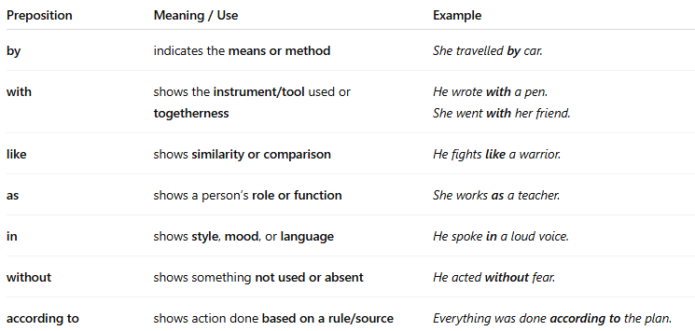
Preposition | Meaning / Use | Example
by | indicates the means or method | She travelled by car.
with | shows the instrument/tool used or togetherness | He wrote with a pen.She went with her friend.
like | shows similarity or comparison | He fights like a warrior.
as | shows a person’s role or function | She works as a teacher.
in | shows style, mood, or language | He spoke in a loud voice.
without | shows something not used or absent | He acted without fear.
according to | shows action done based on a rule/source | Everything was done according to the plan.

📚 Example Sentences
# Source: AI Source: Provided by: [Data Path: Persons Table -> ID Column: 1, Name_En Column: Motasem Essam] -> From: [Chatgpt (GPT-4-turbo)] on [7/28/2025]
- He solved the problem with patience.
- She spoke in English.
- They travelled by train.
- He worked as a manager.
- The child screamed like a siren.

